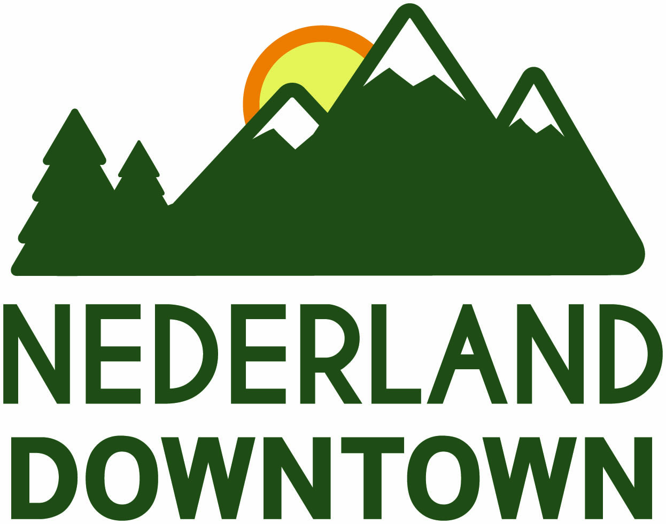

OPEN CALL FOR MURAL ARTISTS
September 2018

The Nederland Downtown Development Authority (DDA) is accepting proposals from artists or teams of artists who wish to be considered to create a mural on
a property in the Downtown District.

PROJECT SCOPE:

The purpose of the mural is to bring a sense of vibrancy and curb appeal to the Nederland Downtown area. The mural locations are to be selected by the Nederland Downtown Development Authority Arts and Culture Committee. The mural will be displayed on the property for a two-year period and will be maintained by the selected artist with support of the DDA.

SUBMISSION REQUIREMENTS:

Enter digital submissions of preliminary drawings of your concept for the mural along with a one-page written proposal. Submissions should be in JPEG format with your name and title identifying the drawing. Artist must be able to provide liability insurance/bond for the mural rendering at location.
Please also include:
A current resume and/or bio with phone number and email address along with 5-10 examples of recent commissioned outdoor/indoor mural projects with a numbered image list identifying titles, sizes, materials used, locations, and approximate costs of these mural projects. Also include proof of liability insurance and bond.

The artist(s) and concepts will be recommended by the DDA Arts and Culture Committee to the DDA Board of Directors, which will make final decision. The DDA reserves the right to not accept any and all proposals and/or content.
Two applicants will be chosen to submit a full proposal. This will consist of: information about design and installation of the mural, including wall preparation, painting supplies, scaffolding, labor, insurance, a budget outline, and a timeline for completion.
Please send completed email submissions to: Josiah Masingale, Executive Director – josiah@nederlanddowntown.org

BUDGET:

The maximum budget for the mural is $1,000.00. The funds shall be used for design, materials, labor, transportation, insurance, and installation costs ie: scaffolding or mechanical lift rental, and other related miscellaneous items, such as travel expenses. Funding to complete this project are provided by the Nederland Downtown Development Authority. There will be funds provided for maintenance if necessary.

DEADLINE FOR SUBMISSION: October 31, 2018

